###### Qualification Strategy

The Qualification Strategy (QS) is a guideline for the user to write the test description. It is useful to target tests more precisely to yield the outcomes required, splitting the HTC into a more strategic selection of TSs and ESs to fulfil the test criteria formulated in the HTC with available RIs.

## Scope

A strategy is the theoretical outline of a possible path to achieve a goal, which can be useful if the goal is not in sight and several (complex) steps are required to reach it. With the terms “validation strategy” or “qualification strategy” we refer to the outline of a path of testing and result evaluation that eventually achieves the qualification of a test object. In contrast to open-ended experimentation, a QS requires a sharp goal and then defines how a given object under test is to be qualified (validated, characterized) by means of a set of tests. The strategy formulation is useful to target TSs and experiments more precisely to yield the required outcomes.

The scope of the QS is to set an implementable plan for what needs to be tested, specifying how objects under test are going to be validated or characterized, considering also the need for characterising properties of the test-bed (research infrastructure) relevant to the test objectives. Effectively QS breaks down the HTC into smaller realizable steps, with the aim of helping in test implementation management and replicability. Two stereotypical situations are considered:

* *Top-down approach:* start from the more global aspects of the test, going down towards more specific items.
* *Bottom-up assembly:* start from the concrete idea to characterize or validate the performance of the object under test and going up towards a general framework.

The developed guideline and an example of its applicability are described in the following sections.

## Formulation of a Qualification Strategy

### Content and Approach of the Qualification Strategy

A complete QS comprises concise goals and a number of ‘steps’ or sub-goals which are further identified as the relations between several different sub-tests. Eventually these sub-tests can be detailed by completing test descriptions in form of holistic TC, TS and ES. Initially however, it is important to establish an overview of the most important components:

1. *What is the actual “object” to be qualified?* (Identified as Object under Investigation (OuI) and Function under Investigation (FuI)).
2. *What new knowledge about the OuI should be established?* (The test objective, refined in the PoI).

Once these questions are clearly identified, it is a question of detailing and refinement to identify the required tests. First, the PoI, OuI and FuI together form the basis for identifying the appropriate boundaries for a System under Test (SuT) and the Domain under Investigation (DuI). Next, the PoI can be translated into more refined Test Criteria (TCR), now that SuT and DuI are known.

Typically, the number of PoI is larger than initially anticipated; and commonly multiple test criteria are required for each PoI. The SuT may also comprise components with unknown dynamics, which require to be characterized first, which, again, can motivate further test criteria.

With the above, the goals and intent of a validation/qualification effort are clear: the identification of the test case. However, certain essential steps are still missing: How will it be possible, by means of a set of experiments, to qualify the regarded PoI? To refine this, the investigator needs to decompose the goal: Which final test will qualify the main PoI? What other experiments are needed to support the evaluation of this main PoI? Are intermediate steps required to mature the OuI for the final setup?

Given a set of test criteria and targets, identified for the final SuT, tests can be devised so that, e.g., they only address a specific subset of the test criteria that achieve an initial validation level that is improved with time (matured), or qualify a component that is required as a factor in another larger test.

Frequently observed situations where the above two questions are not clearly identified include:

* The OuI is identified only in terms of a function name, but not by a system boundary (e.g., “the controller” – OuI or FuI?), and the qualification objective is vaguely identified just with regards to the OuI (e.g., “validate the controller”).
* The SuT is identified and a desired FuI is defined as well, but several components of the test are partly undefined. As a result, any single test would lead to new insight about behavioural aspects of the SuT, but would not be fitting as a qualified isolation of the FuI or OuI (e.g., “test the operation of the CVC controller with several DER” – the SuT is identified, but no test objective is formulated).
* An experimental environment is set up and meant to demonstrate a new functionality of the experimental setup (e.g. a new hardware interface). However, instead of identifying the demonstration/validation goal in the experimental infrastructure, the OuI is identified as some other function that (in a near future) would be possible to qualify with the new infrastructure (e.g. “the fault-ride through controller” as OuI, selected to qualify the practicality of a certain co-simulation or HIL setup).

When a new test is planned, the actual situation can be a mix of any of the above. Such motives and situations stem from good engineering and project management practice. The challenge is rather that the problem framing that results from that practice is not aligned with a validation goal. The framing for a test description must anchor a test objective - and sometimes the test objective is just a means to achieving a project goal.

### Concepts & Notation

*Qualification*

*Qualification* is the more general concept, encompassing other (sub-) purposes of testing, such as *characterization* to quantify e.g. model parameters for a test object, *compliance* or *verification* tests.

*Specification Hierarchy* (see Figure 6)

* TC := {OuI, FuI, PoI, SuT, DuI, TCR, […]}

The TC template includes the definition of OuI, FuI, SuT, DuI, TCR, etc.

* TC 🡪 (TS1 … TSn)

A HTC can require many TSs

* TSi 🡪 (ES1 ... ESn)

A TS can require multiple ESs

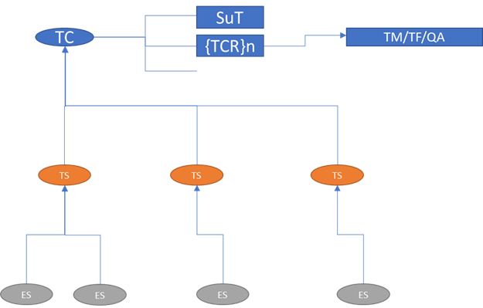

Figure 6: Sketch of the specification hierarchy

*Qualification Dependency* (which TS addresses which of the TC PoI / Test Criteria, see Figure 7)

Test criteria can depend on qualifications from several sub-tests:

* TC.TCR1 🡪 TS1

Test Criteria 1 is qualified in TS 1

* TC.TCR2 🡪 (TS2 && TS3)

Test Criteria 2 is qualified in TSs 2 and 3

But dependency can also be motivated from a system decomposition:

* TC.SuT.ss2 🡪 TS1.OuI

SubSystem 2 is the Object under Investigation in TS 1

* TC.SuT.ss3 🡪 TS3.OuI

SubSystem 3 is the Object under Investigation in TS 3

Either type of dependency needs to be addressed in the formulation of a validation strategy.

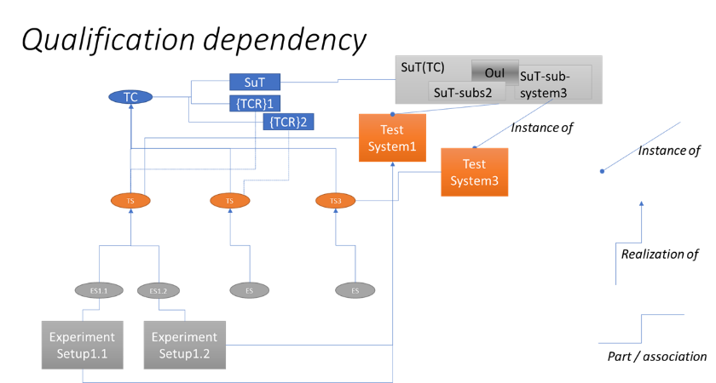

Figure 7: Sketch of the qualification dependency

*Experiment Sequencing*

The order of experiment execution is sometimes driven by the type of validation objective: e.g., if a given OuI is meant to be improved with time, experiments with increased validation complexity need to be sequential; if several components of a SuT need to be qualified first, such tests can be carried out in parallel. Identifying such experiment dependencies can be relevant for project planning.

* E1 < E2

i.e., experiment 1 *before* experiment 2

* E2 | (E3 < E4)

i.e., experiment 2 can be run in parallel with experiments 3 and 4

### Guidelines

To avoid plain theoretical elaborations, the following guidelines will consider *two* stereotypical *situations* motivating the formulation of an experiment description experimentation and eventual reporting. *Situation 1* is the “top-down” situation starting from a given TC description. *Situation 2* is the “bottom-up” situation, where several experiments and RI elements are already clear. In this second case, the challenge is to provide a coherent and analytical frame for a set of experiments to relate to a common and well-defined objective.

*Situation 1: Top-Down Approach*

Given is a TC Case (incl. PoI, FuI, SuT, TCR). The goal would be to define the TSs and eventually experiments that will achieve qualification of the (OuI / FuI) according to your test objectives. This is a typical situation for testing whether some new device or configuration meets some established requirement or standard. The following questions should be answered:

1. *Goal identification and sharpening*

* What goals are achieved by the experiments?
* What is the final or main goal to address your research question?
* What goals are supporting what should be known about your object under investigation?
* Are some of the goals auxiliary to the main goal? (additional ‘nice to have’ information that will not contribute to the main goal)

1. *Collection and Breakdown*

* Identify SuT and Sub-SuTs
* Identify FuTs and clarify Sub-FuTs
* Associate PoIs with OuI and FuI

1. *Precision and Refinement (1st iteration)*

* Do the PoIs and Test Criteria require different testing approaches?

→ formulate sub-sets of test objectives

* Are the Test Criteria directly quantifiable?

→ refine TCR, create TCR-hierarchy

* What factors would influence the test result?

→ consider characterization of test-bed properties

1. *RI-Collection*

* How do the experimental setups reflect a real-world situation? What is the actual object under test/investigation in each experiment? What part of the experiment is the “support structure” for testing that object?
* What can you measure about this object under test/investigation in general?
* What metrics could be quantified by the experiments and how? Which measurements would be needed from the experiments?
* If several experiments are planned with the same reference system, what factors vary between the experiments? (these variations may be interpreted as either test factors, or as nuisances)

1. *Precision and Refinement (2nd iteration)*

* Considering the applicable RI, how are SuT, OuI and FuTs / FuIs realizable?
* Revisit steps 2-4.

*Situation 2: Bottom-Up Assembly*

You have a concrete idea about what set of experiment setups you are planning to implement. All of these experiments are meant to contribute to qualification of a specific research question (e.g., “Validate CVC”). You want to build an analytical frame as a clear context to complement the experiments, so that you can show how the experiment qualifies the research question. This is a typical situation in research, where new requirements can be an outcome of a project. The following questions should be answered:

1. *Collection*

* How do the experimental setups reflect a real-world situation? What is the actual object under test/investigation in each experiment? What part of the experiment is the “support structure” for testing that object?
* What can you measure about this object under test/investigation in general?
* What metrics could be quantified by the experiments and how? Which measurements would be needed from the experiments?
* If several experiments are planned with the same reference system, what factors vary between the experiments? (these variations may be interpreted as either test factor, or as nuisance)

1. *Goal identification and sharpening*

* What goals are achieved by the experiments?
* What is the final or main goal to address your research question?
* What goals are supporting what should be known about your OuI?
* Are some of the goals auxiliary to the main goal? (additional ‘nice to have’ information that will not contribute to the main goal)

1. *Compounding, Breakdown and Assembly:*

* Identify SuT and Sub-SuTs.
* Identify FuTs and clarify Sub-FuTs.
* Associate PoIs with OuI and FuI.

1. *Precision and Refinement*

* Do the PoIs and Test Criteria require different testing approaches?

→ formulate sub-sets of test objectives

* Are the Test Criteria directly quantifiable?

→ refine TCR, create TCR-hierarchy

* What factors would influence the test result?

→ consider characterization of test-bed properties

## Example

The aim of this example is to provide a better understanding of the use of the QS as part of the Holistic Test Description (HTD). The specific example makes use of the Test Case number 2 (TC#2), which refers to the evaluation of a CVC controller. It is assumed that the approach that should be followed in this example is the Top-down approach, namely there exists a detailed TC template regarding TC#2 and from this point the TS and ES templates should be filled out. Therefore, for each of the PoIs specified in the TC template it is necessary to define a list of detailed experiments that qualify these PoIs (see also Figure 8).

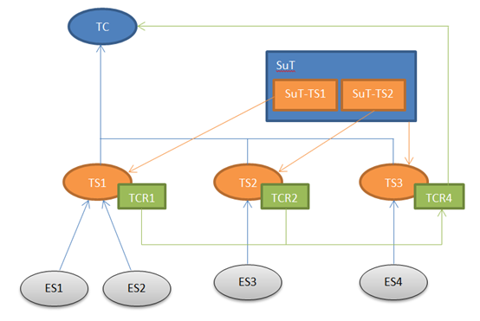

Figure 8: Qualification dependency of the TC#2

Based on the template for the specific TC there is a general PoI with regard to the system. That is the validation of the centralized voltage control scheme applied to a medium voltage grid in order to verify the fulfilment of aggregated requests. To achieve this qualification, the above PoI has been broken down into two PoIs that are more specific:

* Characterisation of a microgrid controller in terms of realizing the requested P/Q setpoints by a CVC
* Characterisation of the CVC controller when the P/Q requests to the microgrid are outside the microgrid controller’s capabilities

In addition, based on the above PoI, the SuT in this TC involves components like:

* Medium Voltage (MV) Grid: Primary substation, lines, loads, generators, On-Load Tap Changer (OLTC) transformer
* MV Grid Controller: CVC
* Controllable DERs (independent of microgrid)
* Low Voltage (LV) microgrid: secondary substation (Point of Common Coupling (PCC)), microgrid DERs (generators, controllable loads, storage systems)
* LV microgrid Controller: P/Q controller at PCC by means of DERs energy management
* Communication Infrastructure

While the target metrics involve:

* Error between measures and the set-points (P, Q, V)
* Error between the nominal voltage and the measurement in each node
* Total cost of the requested actions and total losses
* State of the grid (final State of Charge of each storage system, power quality, etc.)
* Recovery Time

Following the QS, a number of questions can be addressed in order to elaborate the experimental approach that will best meet the requirements of the above PoIs. Goal identification is the first step of the analysis. In this case, the goal of these experiments was identified as the evaluation of the proper behaviour of the CVC controller (i.e., compliance with target metrics). To this end, a supportive goal that should be known about the OuI is obtaining knowledge about the behaviour of a microgrid controller as part of the SuT. Following that, the second step of the QS is a breakdown of PoI that leads to the following list:

* Technology PoI 1 – microgrid
* Technology PoI 2 – CVC
* Technology PoI 3 – microgrid + CVC + MV grid

The third step includes questions aiming at precision and refinement of the TS and ES. The main question considered in this step is about the factors that could influence the test results. As it turns out, these factors are the number of the resources controlled by the CVC or the number of input, the updating time of the measurements and their accuracy, the underlying hardware of the CVC controller and the resources performances (capacity, time response, etc.).

The fourth step in the QS involves the selection of experimental setups (RIs) that meet the TS requirements. The three main aspects addressed by this step is the accuracy with which the experimental setup reflects the real-world system, the actual OuI, and the identification of the parts of the experiments that are supportive to testing the OuI. The elaboration of the PoIs from above leads to the following list of proposed experiments:

* *Technology PoI 1 (TS2 and ES3 in the following diagram):* In this test the OuI is a real microgrid. The microgrid controller receives the P and Q signals and controls its resources in order to follow the set-point. The goal of this TS is to evaluate the performance of the microgrid controller, considering a real microgrid as a black box model.
* *Technology PoI 2:* To reach this PoI, a simple simulation (ES1 in the following diagram) can be performed (to characterize the CVC algorithm) or a CHIL experiment (ES2 in the following diagram) if we want to also test the controller. In this case, the TS1 can be composed of two ES (like a testing chain): first a simulation and then a CHIL test.
* *Technology PoI (TS3 and ES4 in the following diagram):* To characterize the CVC, many operating conditions (different topologies, power flows, etc.) of the grid should be met, so a MV grid emulator or simulator must be used.